Nama : Lilis Sonia

NIM : 18090051

Kelas : 5D

**PRAKTIKUM 1**

1. Source Code

perkenalan.php -> application/controller

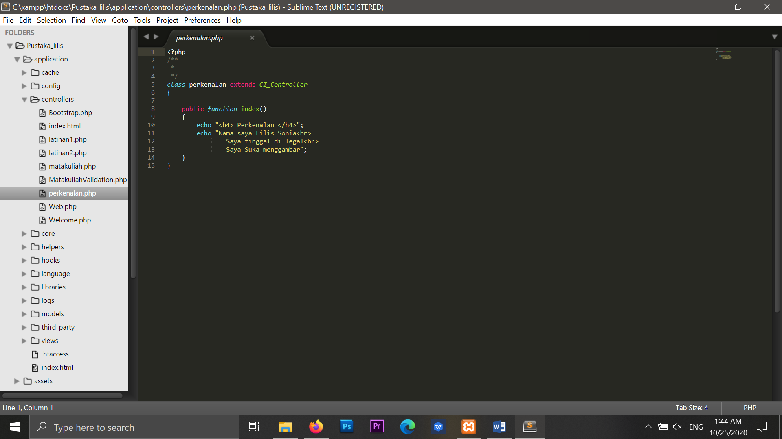

1. URL

<http://localhost/Pustaka_lilis/perkenalan>

1. Capture Hasil

